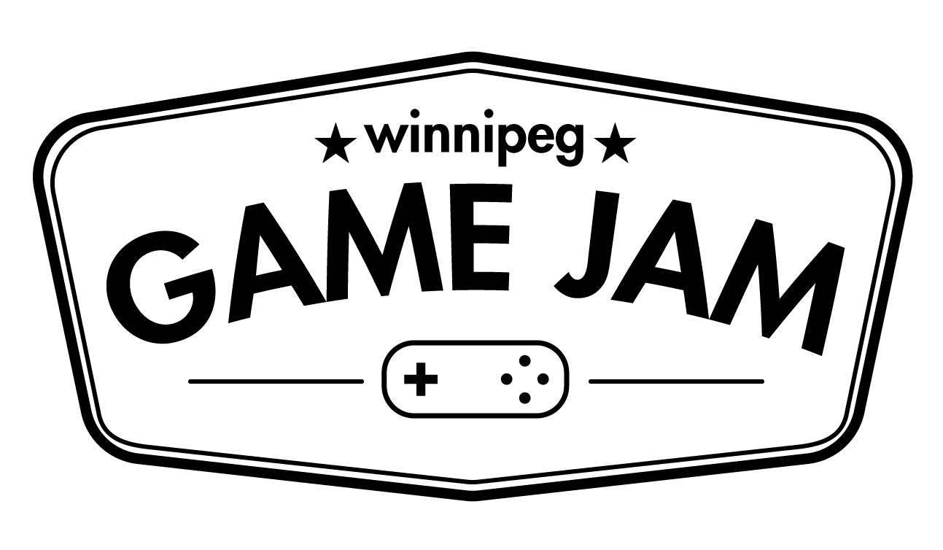

Fire up your Game Engines!

One of the largest game jams in the world, Ludum Dare 35 is the weekend of April 15th to the 18th!
The Winnipeg Game Collective is pleased to present the LD 35 Winnipeg event. It will be hosted at ACI Manitoba located downtown at 245 McDermot in the large classroom located on the 4th floor. For $10 (collectable at the event), you can make games in a friendly, helpful environment surrounded by your peers, as well, it will help ensure that we can continue to run events like this for the community in the future.
Register for the event at: http://www.pegjam.com/ludem-dare-35/
What: Ludum Dare 35
When: Friday, April 15th 6pm-10pm
Saturday, April 16th 9am-10pm
Sunday, April 17th 9am-9pm
Where: ACI Manitoba 4th Floor Classroom @ 245 McDermot Ave.
Why: To make games!
Special thanks goes out to our Premium Gold Partner New Media Manitoba, as well as Electric Monk Media, and ACI for making this event possible.

